Samizdat lessons: three dimensions of the politics of self-publishing

Dr. Endre Dányi
Department of Sociology, Goethe University, Frankfurt am Main;
Member of the Editorial Board of Mattering Press
http://matteringpress.org/

Paper presented at the ‘Disrupting the scholarly establishment’ seminar,
Centre for Disruptive Media, Coventry University, 7 March 2014

Introduction

- The term ‘mattering’ in Mattering Press comes from science and technology studies. STS, as this field is usually called, brings together a growing number social anthropologists, sociologists, human geographers, cultural economists and many others with the aim of problematising science’s self-understanding as a disembedded and disembodied undertaking. STS scholars usually do this problematising work by making the actual places and material practices associated with science more visible – not in order to discredit them, but in order to reintroduce them as legitimate objects of social research.

- STS as a field itself was established in the late 1970 and early 1980s, when the first ethnographic studies of some Western European and North American laboratories were published by Bruno Latour and Setve Woolgar ([1979] 1986), Karin Knorr-Cetina (1983), and Michael Lynch (1986). Since then, STS scholars have extended their gaze to a wide range of sites, from hospitals through high-tech innovation centres to stock exchange trading rooms, in order to explore how scientific knowledge is being produced and distributed through seemingly trivial material practices – and how it could be produced and distributed otherwise.

- Ironically, what’s largely missing from the list of usual sites in STS-inspired works are the institutions that play one of the most important roles in shaping the academic world STS scholars themselves operate in, namely publishers. To address this hiatus, Mattering Press was established in 2012 by a small group of young scholars to better understand current developments in academic publishing by actively participating in them. We’re an Open Access publisher that publishes peer-reviewed, empirically grounded monographs and edited collections of various formats.

Although all of us at Mattering Press come from STS, we have different interests in this ongoing experiment. Some of us see it as a new way of keeping together an academic community, while others like to think of it as a potentially sustainable model for Open Access publishing. I’m personally fascinated with is what could be called the ‘politics of self-publishing’. In this short paper I will try to articulate what such a politics might mean using the case of illegal – samizdat – publishing in Hungary in the 1970s and 1980s. First, I will briefly recount the history of samizdat production in Central and Eastern Europe in general and in Hungary in particular. Drawing on STS insights, I will then identify three dimensions of self-publishing. Finally, I will discuss how these three dimensions are simultaneously present in the term ‘mattering’, which has been the organisng concept behind Mattering Press.

Samizdat histories

The term ‘samizdat,’ coined by the Russian poet Nikolai Glazkov in the early 1950s, means self-publishing and refers to both the various processes of producing texts unauthorised by the state, and the outcomes of those processes: mostly literary and political writings that could not have appeared in official periodicals (Bock et al., 2004; Gereben, 1986; Komaromi, 2004). In the Soviet Union until the mid-1950s, samizdat activities were limited to circulating handwritten manuscripts or a few copies of uncensored typescripts among friends and colleagues. In the scholarly literature on Russian samizdat, this period is often referred to as the ‘pre-Gutenberg’ era of opposition (Komaromi, 2004: 598), as it was practically impossible to get access to more advanced printing devices. As Skilling (1989) reports, it was only a few years after Stalin’s death when a wider group of people began to reproduce and pass on uncensored writings – even without the authors’ consent. From the late 1950s onwards, some illegally published journals and books (such as less-known works of Bulgakov, Pasternak and Solzhenitsyn – see Figure 1) could reach a much wider readership by getting Western publishing houses involved in the production process (see Feldbrugge, 1975).

Figure 1: Manuscript of Alexander Solzhenitsyn’s The Gulag Archipelago

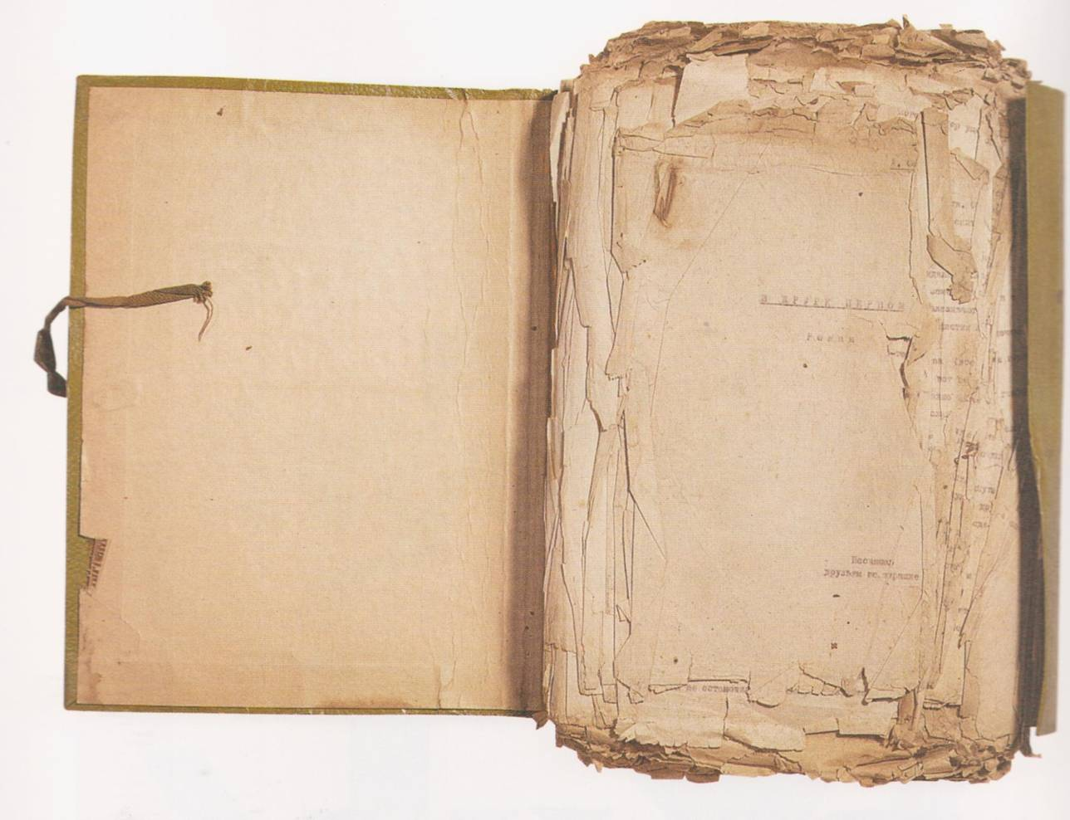
Source: Bock et al., 2004: 224.

The relative success of literary samizdat in the Soviet Union was followed by the gradual appearance of more explicit political writings, such as open letters, appeals, even manifestos. Political samizdat, according to Skilling, ‘began to fulfil the function not only of a book but of a newspaper’ (1989: 6). Perhaps the most important periodical of this kind was The Chronicle of Current Events, which regularly contained reports on violations of human rights (see Figure 2). Skilling estimates that the circulation of The Chronicle was between 1,000 and 10,000, with a readership between 10,000 and 100,000. As the number of copies of illegally published texts kept increasing, those who were writing, distributing, or even reading samizdat, risked constant harassment by the secret police. In order to prevent imprisonment and confiscation of manuscripts and printing technologies by the authorities, dissidents formed various networks in which sensitive information, printed texts, money and other objects could be transmitted in an (almost) anonymous manner. There were separate mechanisms for commissioning or translating articles, getting them published and distributed, then collecting the money for them and sending it back to the publishers. Sometimes instructions as to what to do with the text were printed in samizdat journals themselves (for example, ‘read it, copy it, and pass it on’, or information on where to look for previous issues – see, for example, Demszky, 1990).

Figure 2: The Chronicle of Current Events, No. 35 (31 March 1975)
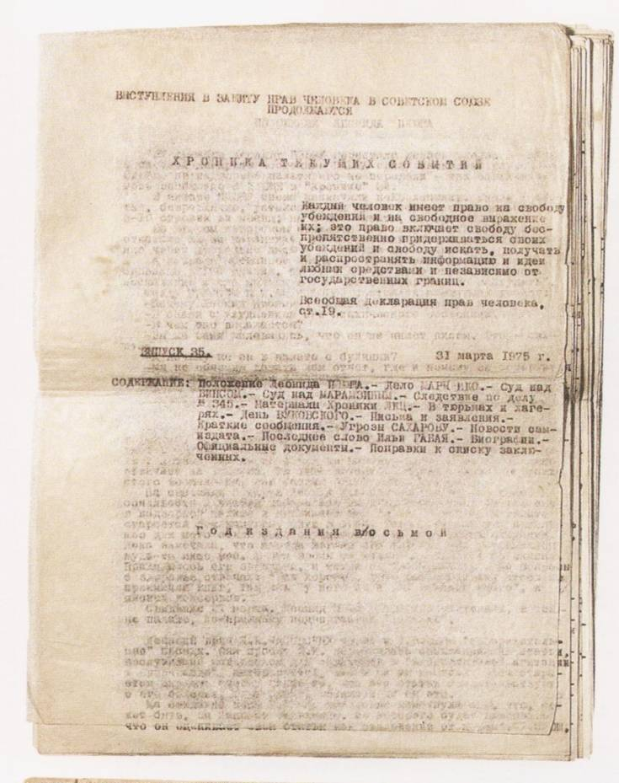
Source: Bock et al., 2004: 204.

Outside the Soviet Union, samizdat activities in one form or another, existed in many Eastern Bloc countries, but the most developed network was to be found in Poland (Skilling 1989). While East-German, Czechoslovakian and Hungarian samizdat authors in the 1970s were still preoccupied with getting their typescript copied and circulated, their Polish friends already had their own newspapers (Bock et al., 2004), printed stamps and sold them illegally to cover the costs of their activities. No wonder that most dissidents in Central and Eastern Europe wanted to follow the ‘Polish path’, as small delegates of the Hungarian opposition, for instance, regularly visited Adam Michnik and his circle to learn new printing techniques and smuggle more advanced devices back to the country (Haraszti, 2004).

* * *

The history of Hungarian dissent and samizdat begins in the late 1960s, although some illegally published poems and novels had been around since the early 1950s (Gereben, 1986). As Miklós Haraszti argues, the first steps of those critical of the regime were aimed at breaking with the post-1956 practices of self-censorship (2004: 76). Initially this was much more of an artistic ambition, rather than an explicitly political mission. One of the most exciting places where avant-garde artists, political philosophers and other groups labelled as ‘deviant’ by communist authorities could gather to experiment with new forms of expression was at a chapel at Balatonboglár, rented by György Galántai, painter and founder of the art research centre Artpool (see Klaniczay & Sasvári, 2004). Each summer between 1970 and 1974, dozens of people moved into the chapel and the surrounding field for a few weeks to present their art or theoretical work. These summer events were more than simply occasions to meet like-minded people from all over the country: as Tamás Szentjóby, one of the ‘action artists,’ put it, the performances that took place in the chapel were ‘punishment preventive auto-therapies’ (see Figure 3). While many Hungarian samizdat authors – including Haraszti – contend that the organised political opposition of the 1980s has its roots in the Balatonboglár sessions, according to some art historians and aesthetes it would be too farfetched to claim direct connection between the two periods (see, for example, György, 2004). Still, it is undeniable that the lectures presented and artworks exhibited at the Chapel often conveyed serious political messages – which, consequently, led to the official closure of the Chapel in 1974, and to the forced emigration or arrest of many of the Balatonboglár artists (Csizmadia, 1995).
Figure 3: Tamas Szentjoby’s performance in Balatonboglar, entitled
‘Exclusion exercise: punishment preventive auto-therapy’ (1972)
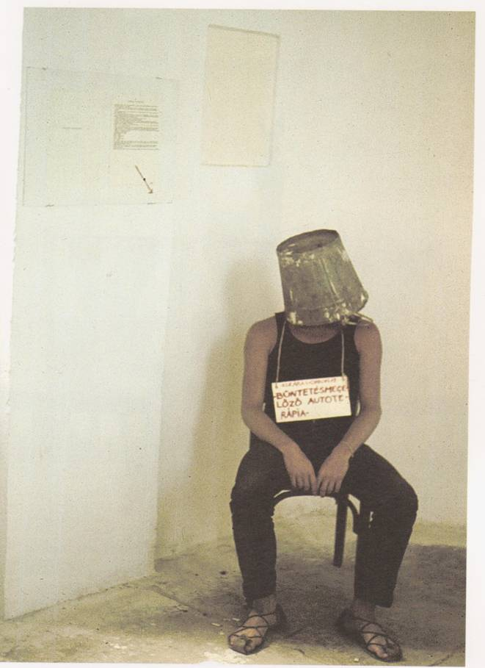
Source: Bock et al., 2004: 243

After Balatonboglár, it proved to be impossible to keep different strands of alternative artists and political ‘troublemakers’ together. For years there was virtually no samizdat publishing in Hungary. To quote Haraszti again, ‘in the seventies an optimist was someone who had the courage to write about her pessimistic presentiments’ (my translation – see Haraszti, 2004). The turning point was probably late-1976, when the first major Hungarian political samizdat work was published: a collection of 20 critical essays dealing with ‘Marxism in the fourth decade,’ edited by András Kovács (Gereben, 1986: 16). A few months later, this was followed by an open letter signed by 34 Hungarian intellectuals, announcing their solidarity with the authors of Charter 77 – Jan Patocka, Václav Havel, Jiri Hájek and others’ manifesto criticising the Czechoslovak government for repeatedly violating human rights. In the coming years, a few more important clandestine books appeared, such as the 800 page-long Profil, a collection of essays by ‘non-Marxist authors, all of whom had submitted their works to official journals, which had rejected them as “not fitting our profile” ’ (Skilling, 1989: 32), and the 1000 pages long Bibó Emlékkönyv (Bibó Memorial Book – in honour of political thinker and minister in the 1956 government István Bibó, who died in 1979). Sociologist László Bruszt argues that these publications can be considered ‘genre experiments,’ with the Hungarian Observer and the East European Observer – relatively regularly published magazines reporting on domestic and foreign affairs – being closest to the ‘standard’ format of samizdat periodicals of the 1980s.

Figure 4: Cover pages of four Hungarian samizdat books published by independent publishers in the early 1980s (clockwise: Miklos Haraszti’s The Aesthetics of Censorship, Gyorgy Konrad and Ivan Szelenyi’s The Intellectuals on the Road to Class Power, Gaspar Miklos Tamas’ The hand and the eye, and Istvan Bibo’s On the Hungarian Revolution)

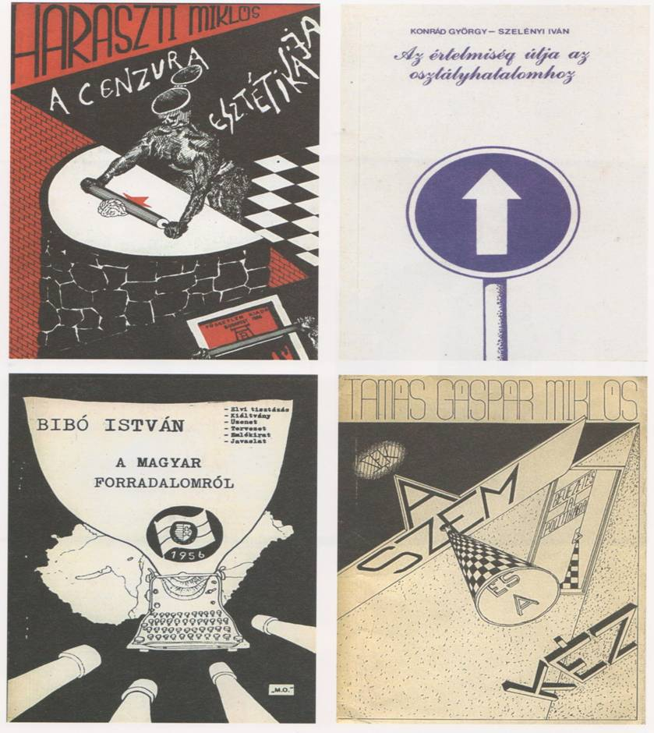
Source: Bock et al., 2004: 214

In 1980-81, partly influenced by the successes of the Polish independent press, the number of illegal publishing houses proliferated in Hungary (Csizmadia, 1995; Gereben, 1986). Gábor Demszky’s AB Independent Publisher, for example, commissioned essays on such ‘taboo topics’ as the 1956 revolution and the everyday struggles of Hungarian minorities in neighbouring countries (see Figure 4). Other publishers debuted with works of banned Hungarian and foreign authors, such as Arthur Koestler or George Orwell (Skilling, 1989). The first ‘bookstore’ for samizdat publications (the so-called ‘Rajk-boutique’) was established in 1980, in László Rajk Jr’s apartment: on Tuesday evenings anyone could show up and order or buy copies of uncensored writings (Haraszti, 2004; Krahulcsan, 2001). A few hours after the ‘market day’ came to an end dozens of typists all over Budapest started to work on subsequent copies of samizdat books and articles.

As a result of the gradual institutionalisation of samizdat production and dissemination, in 1981 the first issue of the most influential Hungarian samizdat periodical, the quarterly Beszélő (an untranslatable play with the word ‘speaker,’ which refers to both a person speaking, and the room where prisoners could meet their visitors) could appear in ca. 1,000 copies (Skilling, 1989), followed by a circulation of 2,000 for subsequent issues (Haraszti, 2004). Until 1983, Beszélő was virtually the only serious regularly published samizdat periodical, which had quickly become (and until 1990 remained) the flagship of the Hungarian democratic opposition (Csizmadia, 1995). The aim of the founder-editors’ – Miklós Haraszti, János Kis, Ferenc Kőszeg, Bálint Nagy and György Petri, Ottilia Solt, and Sándor Szilágyi (see Figure 1), was to create a ‘parallel’ or ‘second society’ in Hungary (see Hankiss, 1986) where all political topics could be discussed openly. Public debates around touchy subjects (such as, the 1956 revolution, poverty in socialist countries, economic and ecological crises, human rights violations, corruption, and so on), they believed, would slowly de-legitimise the Communist regime.

Although most political sociologists and historians agree that compared to Polish, Russian, or Czechoslovak dissident movements, the Hungarian was rather weak and limited in scope (see especially Skilling, 1989), it is fair to say that Beszélő and other samizdat journals played a crucial role in contesting the limits of the system and provoking public dialogues between incumbents and insurgents, which then gradually transformed into the Roundtable talks of 1989 and, eventually, the non-violent change of the regime in 1990.

Questioning three assumptions of samizdat research

In the previous section I tried to re-construct a ‘received’ version of the history of independent publishing in Central and Eastern Europe in general, and in Hungary in particular. When working on this task I was surprised to see that most academic books and articles published on the subject are very similar in their assumptions and methods, despite obvious differences in cultural contexts and forms. Discussions on the political significance of independent publishing are generally centred around texts, the contents of journals and books, while the material aspects of their production, distribution and consumption are considered to be circumstantial. Moreover, researchers usually see samizdat in the Soviet Union and in other Eastern Bloc countries as outcomes of organised dissent and resistance movements, thus reinstating well-known Cold War narratives (according to which the overall aims of those involved in samizdat activities was to bring down communist regimes and establish free and democratic societies). Finally, in current scholarly literature samizdat as a political object is, by and large, considered obsolete, a ‘somewhat embarrassing and wretched’ (Komaromi, 2004: 603) information carrier of the past. The aim of this section is to examine the three above-mentioned assumptions of research in this field in greater detail.

- Materiality
The main ‘selling points’ of samizdat research are the physical appearance of illegally published texts and the fascinating printing devices behind them (Figure 5). As renowned images of battered pages (see Figures 1 and 2) testify, ‘doing politics’ in samizdat circles was a truly physical business: first, one had to acquire and assemble the primitive printing machines, commission and collect manuscripts, get paper and ink, and then work during the night without letting anyone notice anything suspicious. The distribution of the printed material was no less demanding: the nature of conspiracy required everyone to get as much work done as possible – preferably alone (Hodosán, 2004). Furthermore, most of those involved in illegal publishing were under state surveillance: the constant threat of house searches or random ‘visits’ by the secret police tried both the body and the soul (Krahulcsán, 2001).

Figure 5: This is a stencil machine used by Hungarian samizdat publishers
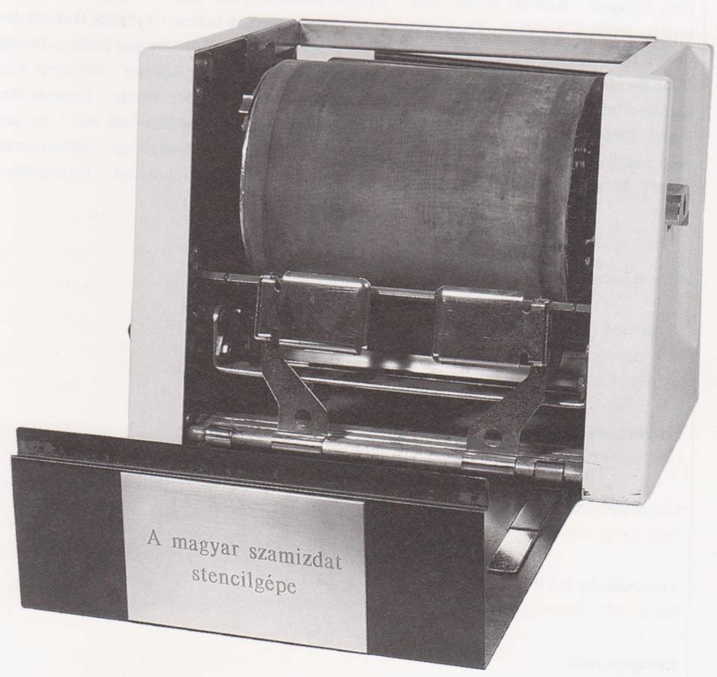

Source: Bock et al., 2004: 263

Exciting or upsetting stories of such adventures are standard elements in academic works on samizdat. Interestingly, however, in most cases technical-material aspects of text production appear merely as circumstantial details; it is the texts themselves that are considered to be important. According to the dominant view in samizdat research, the aim of these texts was to report the ‘real’ conditions in communist countries, to ‘transmit the “truth” suppressed in the official world of state censored publications’ (Komaromi, 2004: 600). However, the contents and material existence of samizdat can hardly be analysed independent of each other. To quote Komaromi again, ‘the amateur typescript, the deformity of the text, the characteristic mistakes, corrections, fragile paper, and degraded print quality had value because they marked the difference between samizdat and official publications’ (2004: 609; emphasis in the original). Moreover, building upon Jacques Derrida’s concept of the written ‘trace,’ Komaromi argues that there was an element of ambiguity in the relationship between the physical from and the idealised content. Unlike officially published texts, samizdat articles got constantly modified by copyists, while authors had practically no control over the life of their own writings. In many cases ‘the message’ central to mainstream samizdat research existed in so many versions that it became of secondary importance compared to the symbolic value of the text-object itself.

Clearly, the materiality of texts matters – classical political philosophical approaches based strictly on the analysis of disputes and discourses simply remain blind to this fact (see Law and Mol, 2007). The material characteristics of samizdat had crucial roles in the constitution of ‘the truth’ about human rights issues, cultural policies, economic reforms, political events, etc. in dissident circles in the Eastern Bloc. By going beyond the strictly textual analysis of samizdat it becomes apparent that text-objects are never innocent: they are ‘intelligible only under very special conditions’ (Warner, 1990: xi). The researcher suddenly has to deal with a set of questions very different from those concerned with rational arguments or the correct sequence of political events, such as: What counts as samizdat? Who can be a samizdat author? Who are the addressees? What can be discussed, when and how? Building on Michael Warner’s (1990) insightful work on writing and print in the Colonial America I will refer to the ‘power-laden but silent decisions’ (ix) on such questions as the metapolitics of (illegal) publishing.

Komaromi’s elegantly written article on the material existence of illegal publications in the USSR is a major step towards a different kind of samizdat research, one that recognises heterogeneity and focuses on text-objects, rather than texts only. However, in order to apprehend the metapolitics of illegal publishing a further step is needed. One has to deal with not only the materiality of samizdat books and periodicals, but also what Robert Darnton calls the ‘communication network’ around the printed material (see Johnston, 1999). Darnton’s work (1982, 2000) on underground literature in 18th century France examines in an exemplary fashion the ‘life cycle’ of a wide range of printed materials – most of which had been considered too heterodox for the main cultural institutions of the Old Regime (including the monopolistic guild of booksellers) to be sold ‘over the counter.’ Darnton’s main argument is that if one is to study the literary circles of the Enlightenment it is not enough to catalogue what texts people read:

I would like to urge the importance of going beyond the books in order to confront a new set of questions: How did writers pursue careers in the Republic of Letters? … How did publishers and booksellers operate? Did their ways of doing business influence the literary fare that reached their customers? What was that literature? Who were its readers? And how did they read? (Darnton, 1982: viii)

In light of Darnton’s proposal, samizdat in the Eastern Bloc appears less as a distinctive text object, and more as the result of complicated processes that required the co-operation of a whole range of actors including authors, typewriters, editors, sometimes graphic designers, low-tech (or, occasionally, high-tech) printing devices, distributors with vans, and so on. It was also the beginning of subsequent processes in which the periodical got borrowed, secretly photocopied, collected, read and discussed, and, no doubt, analysed by the authorities.

One way of attending to both the materiality of the text and the heterogeneous network around it is to consider samizdat not as a text-object, but a network object – a term well-known in Actor-Network Theory literature (see Law, 1986; Law and Singleton, 2005). Objects, in this sense,

… display – may be understood as being constituted in – a double immutability. On the one hand, they probably have a more or less stable shape in physical space …. On the other hand, they certainly have, display or are constituted by a more or less stable structure in a network of relations. Stability … is sustained in two separate and partially related ways. (Law and Singleton, 2005: 336-337)

Seen this way, samizdat as a ‘network object’ served as a more-or-less stable media technology and established or reinforced connections among various actors and locations (such as university cafés, private homes, research institutes) – mostly within, but sometimes across country borders. In other words, samizdat as a network object created its ‘samizdat worlds,’ it defined political spaces. Unlike in most strands of media studies and political theory, however, political spaces here are conceived of not as clearly defined, text-centred ‘imagined communities’ or ‘reading publics,’ but as spaces of relations and configurations – never finished, never closed (see Law, 2002; Law and Hetherington, 2000; Massey, 1992, 2005; Suchman, 2005).

- Resistance
How should we think of the political spaces of samizdat? In the library of the Budapest-based Central European University, academic books written on samizdat in the Soviet Union and Central and Eastern Europe can be found under the following labels: ‘dissent,’ ‘political opposition,’ ‘resistance,’ ‘underground literature,’ ‘alternative culture.’ What is common amongst these labels is that they all refer to a cultural/political realm that supposedly exists/existed in opposition to an institutionalised, oppressive, ideological regime. At first glance this categorisation of samizdat appears to be absolutely right: there is no doubt that the Communist regimes of Hungary and other Eastern Bloc countries were oppressive, ruthless and brought about injustice, deprivation and (physical and emotional) suffering for millions of citizens. Before 1990, anyone criticising the system was considered to be a reactionary, counter-revolutionary element, an imperialist, the enemy of the people – and, not surprisingly, were treated as such by the state, as is demonstrated by secret police reports. Thus, associating samizdat producers and authors with resistance by all accounts seems to be justified.

However, the dualism of the ‘Communist regime vs. illegal opposition’ or ‘oppressive power vs. resistance’ is not as unproblematic as it may first seem. In his book, Domination and the Arts of Resistance: Hidden Transcripts, James C. Scott (1990) sets out to analyse ‘subordinate’ or ‘powerless’ groups and various forms of their political conduct. Central to his work is the differentiation between public and hidden transcripts: the former refers to the ‘self-portrait of dominant elites,’ whereas the latter signifies specific forms of disconsent or (usually veiled) critique. By reviewing a diverse set of cases of domination and resistance – from Caribbean slavery to political dissent in Gorbachev’s Russia – Scott aims at developing a general theory of the ‘technology and practice of resistance’ (1990: 20).

Although his work is intended to be analogous to ‘the technology of domination,’ Scott’s understanding of power is very different from that of Foucault (1979). In Domination and the Arts of Resistance, subordinates, servants, slaves, dissidents etc. are identified as individuals without power; as if power was something that can be possessed (similar to money or weapons). This conceptualisation of power has been scrutinised – among others by Foucault himself. Where does power stem from? How is it exercised? With what effects? Identifying powerful and powerless groups and examining their relationship to each other yield only partial answers to these questions. Perhaps it is more adequate, as John Allen argues (1999, 2004), to conceive of power as a relational effect of interaction, something that is ‘not so much above us, as around and among us’ (1999: 201-202). And so, what does this mean in the samizdat case?

In an essay entitled ‘The terrifying mimicry of samizdat’ Serguei Oushakine criticises Scott for locating resistance outside of the field of power – ‘be these “hidden” areas in the underground, background or foreground of the dominant’ (2001: 192). Through the analysis of illegal publishing in the Soviet Union between the late 1960s and late 1970s Oushakine argues that the topics and the ways in which dissidents discussed them were ‘largely framed by existing public discourses on Soviet law and civic and human rights’ (2001: 196). In other words, drawing on Foucault’s work on progressive politics (see Foucault, 1991), he claims that those involved in samizdat activities mimicked and thus actively reproduced the dominant political order.

Dissidents questioned not so much the principles of the existing political order but rather their implementation. For the majority, the issue was not whether socialism was feasible at all; it was too real to have any doubts about its existence. Instead, to quote the title of an influential samizdat article, the main question was: “Is a nontotalitarian [sic!] type of socialism possible?” (Oushakine, 2001: 199)

While Oushakine is right in criticising the myth of ‘the political underground’ as a separate space of resistance and pointing out the difficulty with drawing lines between ‘official’ and ‘unofficial’ discourses, his central concept (i.e. the mimicry of dissidents) presupposes the pre-existence of a single dominant position, which then gets imitated and/or gradually transformed by samizdat authors. Arguably, one of the problems with this argument is that it offers a rather simplistic image of ‘Kremlin politics’. But, perhaps more importantly, it also overlooks an important aspect of samizdat activism: as the quote above shows, the subject of discussions in dissident circles (in Moscow, just as much as in Prague, Warsaw or Budapest) was not necessarily the fate of the political system, but different ideas of ‘a better society’.

There is nothing special about dissidents under communist regimes in this respect. After all, coming up with visions of the perfect society has been a common practice since at least Thomas More’s Utopia was first published in 1515. As Kevin Hetherington (1997) explains, ‘utopia’ is a play with the Greek words ‘eu-topia,’ meaning good place, and ‘ou-topia,’ meaning no-place. Utopia, therefore, is supposed to be a good place that does not exist – or exists only in our imagination. By contrast, Foucault coins the term ‘heterotopia’ to denote existing places that function as ‘counter-sites, a kind of effectively enacted utopia in which the real sites, all the other real sites that can be found within the culture, are simultaneously represented, contested, and inverted’ ([1967] 1986: 24). Referring to Hetherington again, heterotopia literally means ‘place of otherness’ – a place where different realities are enacted. In The badlands of modernity Hetherington focuses on three historic cases – the Palais Royal in Paris before and during the French Revolution, masonic lodges, and factories in England in the 18th century – and shows eloquently that various ideas of ‘good and ordered societies’ are not simply future-oriented fictions, but are always performative. By analysing heterotopia, Hetherington suggests, one gets closer to the understanding of the ways in which spaces ‘that were to have a lasting impact upon the development of modern ideas and their visions of social order and ordering’ (1997: 56) were produced.

In the previous sub-section of this paper I argued that samizdat as a network-object – by connecting a wide range of actors involved in the production, multiplication, distribution, interpretation, discussion, etc. of illegal texts – defined certain political spaces in Eastern Bloc countries. My aim with this sub-section was to show that instead of thinking of these spaces as sites of resistance – as many researchers contend – it is perhaps more appropriate to consider them as heterotopia, that is, spaces where alternative (political) futures could be dreamt of and realities could be enacted. In the next sub-section I will briefly discuss what importance these alternative realities might have after the political transition of 1989-90.

- The relevance of an obsolete object
If we take the original definition as a starting point (according to which illegal or independent publishing and state censorship mutually constitute each other – see Kőszeg, 1987), then samizdat, both as an object and a publishing technique, clearly belongs to the past (Bock et al., 2004). Long gone are the days when in Central and Eastern Europe one could get arrested for owning (not to mention producing or distributing) political texts banned by the state. Today, when freedom of the press is guaranteed by a wide range of institutions and regulatory bodies, and citizens have numerous ways to make their voices heard without having to wait for any censor’s verdict, ‘independent publishing’ sounds much more like a form of trendy enterprise, rather than a risky political act.

Indeed, the only places where samizdat material can be found these days are temporary exhibitions or archives (for example, in the collection of the Open Society Archives). Located in these institutions, the once illegally published texts serve as ‘obligatory passage points’ for historians interested in the fall of communist regimes, but are considered to have no relevance whatsoever to contemporary politics. But is this right? Are the walls of the archives also the boundaries between the past and the present? Frequent references in actual public debates to dissident activities in general, and samizdat production in particular suggest that this is not quite the case. A quote from István Rév captures nicely that ‘pasts’ – never singular, never complete – are entangled with the present in complex ways:

1989 was a liberating moment. In the context of the political events, the received, lived, remembered past seemed just not to make sense anymore. In the face of this dead end, the past lost its meaning both for the believers and for the sceptics: for the perpetrators, the collaborators, and even for the dissidents. An alternative story was needed, in the context of which the mosaics … of the past could be rearranged and given new, proper places in the chronology. (Greenblatt, Rév and Starn, 1995: 9)
Following this train of thought, it can be argued that while samizdat production as a political practice has become obsolete after the political transition, samizdat periodicals have gained a new function. They now make certain ‘rearrangements of the mosaics of the past’ more feasible than others. In the archives, they are transformed into quiet informants that exist to tell and re-tell the origin stories of democracy in Central and Eastern Europe. In these stories, as I briefly discussed in the previous sub-sections, dissident circles under communism generally appear as the ‘Eastern outposts of democracy,’ which – through illegal publishing and related activities – opened up the possibility of free speech, the acknowledgement of human rights, and paved the way for emerging civil societies. My aim is not to debunk these depictions. They are not wrong per se, but they usually forget all about heterotopias and the multiplicity of political realities samizdat epitomised, and suggest that the world before 1989, just as today, can be divided into two groups: friends and enemies of democracy.

In her critique of the rationalist deliberative model of democracy Chantal Mouffe (2005) observes that the ‘we’/’they’ opposition so central to democratic politics is ever more often constructed according to the moral categories of ‘good’/’evil.’ According to Mouffe, this indicates ‘not that politics has become more moral but that nowadays political antagonisms are being formulated in terms of moral categories’ (2005: 75). The problem with this ‘moral turn’ is that it makes groups of citizens think of their political opponents not as ‘adversaries’ but ‘the enemy,’ with whom any discussion, any attempt to reach a consensus is pointless. Using the example of right wing populism in Austria, Mouffe convincingly argues that the rise of extremist parties and movements in Western democracies occurs not because the political systems are weak, but because current democratic practices emptied out the political space where different hegemonic political projects could be confronted. And, the argument continues, ‘when social division cannot be expressed because of the left/right divide, passions cannot be mobilised towards democratic objectives and antagonisms take forms which can endanger democratic institutions’ (2005: 120).

In Hungary – as well as in many other post-communist countries – democracy is constantly thought to be under threat by not one but two bogeys: the far-right and the far-left. Claiming that someone is/was a communist is an accusation that effectively says he or she is not (and can never be) a democrat. Of course, the criteria of being a communist keep changing, but various documents, including samizdat articles and official reports of the pre-1989 secret police, can give some of the accusations serious weight. Building on Mouffe’s argument I would like to suggest that the tendency to divide the political world into friends and enemies of democracy should not be regarded as a sign of ‘incomplete democratisation’ in Central and Eastern Europe, but as a side-effect of a particular ‘post-political’ understanding of democracy: one that treats alternative political realities ‘anti-democratic.’

In the previous sub-sections I have argued that what made the political spaces of samizdat in the Eastern Bloc interesting was not necessarily the cause of ‘bringing down communism,’ but the often incoherent co-existence of various political realities. To overcome the limitations stemming from associating samizdat with resistance I introduced the term ‘heterotopia,’ or ‘places of otherness’ where alternative political futures could be dreamt of. In this sub-section I have tried to show that although both samizdat production as a political practice and related heterotopias disappeared after the regime changes of 1989-90, it does not mean that samizdat, this obsolete political object, has lost all relevance to contemporary politics. As I have discussed, once illegally published writings have an important role in telling the ‘origin stories of democracy’ in Central and Eastern Europe. But what might make them even more exciting as analytical tools is that they can help to identify heterotopias, alternative political spaces that do not quite fit the ‘government vs. opposition’ and ‘friends vs. enemies of democracy’ dualisms. In the last section I will discuss how such a research project would fit with current discussion on publishing practices within Science and Technology Studies (STS).

Discussion: researching different modes of mattering

In the Introduction I claimed that the aim of this paper was to go beyond the technical/political dichotomy prevalent in political thinking, and focus on the illegal publishing of manifestos, open letters, literary works and other uncensored writings in the Eastern Bloc as a material practice. Explicitly and implicitly, I relied strongly on Science and Technology Studies literature when re-conceptualising samizdat as a ‘network object.’ Now I would like to make the link between samizdat research and STS even more direct, and show how the study of different political spaces might contribute to ongoing discussions within science studies about the technologies and techniques of political practices.

STS in general, and Actor-Network-Theory in particular, has been widely criticised for not paying much attention to, or being naïve about mainstream politics. In some of his current writings, Bruno Latour (2004, 2005b, 2007) attempts to respond to some of these observations. As a point of departure, he contends that in politics, as well as in other aspects of life, we are witnessing the crisis of representation. Parliaments as once dominant techniques of political representation in the West have become mostly irrelevant because they cannot keep up with the rapidly changing political environment they were supposed to operate in. What can one’s MP do to fight climate change? Or bring down the price of Russian gas? Or stop the EU telling how tomatoes should look like? Clearly, not that much. But this does not mean that we have to get rid of the idea of representation altogether. Latour argues that there are many other forms of representation – ‘each has its own architecture, its own technology of speech, its complex set of procedures, its definition of freedom and domination’ (2005b: 31). Therefore, instead of sticking to a single standard way of tackling all the issues that may arise in our societies we’d better identify the ‘objects of politics’ first and only then look for a form of representation – a socio-technical assemblage – that best suits our purposes (Marres, 2005, 2007). The task of an STS-informed ethnography of politics, then, would be to show how these assemblages are formed and work in practice (Barry, 2001: 176-177).

There are many fascinating examples of such ‘hybrid forums’ and ‘alternative forms of political representation’ in action – from low-scale conversations around the kitchen table to the regular meetings of the UN Security Council. Despite many differences in shapes and sizes, however, these assemblages have one thing in common: they are all pulled together by a common issue or a ‘matter of concern’ (Latour, 2004). But where do issues come from? Who defines them, and how do they become ‘objects of politics’? Surely, in some cases, it seems obvious what the important issues are, and who the relevant actors could be. But, as for example John Law and Annemarie Mol (2007) show in their paper on the 2001 outbreak of foot and mouth disease in the UK, there are cases where the identification of issues require serious work. Moreover, this work does not necessarily have to be discursive in kind. Law and Mol argue that material practices (in their case ‘boiling pigswill’) can become political as they make alternative realities contrastable. So it is not only that issues or ‘matters of concern’ can be discussed/contested/analysed/solved in many different ways, in many different settings. It is also that there are various ways of making certain issues matter – there are different modes of ‘mattering’ (see Law, 2004). This suggests that the material aspects of political practices and political issues are linked in exciting ways. Samizdat publishing, in this sense, can be viewed a specific mode of mattering; one that was very different from ‘governance’ or ‘resistance.’ It allowed for the co-existence of different political realities – and this is something worth examining in greater detail if we are to overcome the negative consequences of the ‘democratic’ vs. ‘anti-democratic’ opposition discussed by Mouffe.

References

Allen, J. (1999) ‘Spatial assemblages of power: from domination to empowerment’ In Massey, D., Allen, J. Sarre, P. (eds.) Human Geography Today,
Allen, J. (2004) ‘The whereabouts of power: politics, government and space’ Geografiska Annaler, 86B (1), pp. 19-32.
Barad, K. (2003). Posthumanist performativity: Toward an understanding of how matter comes to matter. Signs, 28(3), 801–831.
Barry, A. (2001) Political machines: governing a technological society, New Brunswick, NJ, Athlone Press.
Becker, H. S. (1984) Art worlds, Berkeley; London, University of California Press.
Bock, I., Eichwede, W., Hamersky, H., and Schlott, W. (2004) ‘A Kiállítás,’ [The Exhibition] In Rissmann, E. (ed.) Szamizdat: Alternatív kultúrák Kelet- és Közép Európában 1956-1989, Budapest: Stencil Kiadó-Európai Kulturális Alapítvány.
Callon, M. (1986) Elements of a sociology of translation: Domestication of the Scallops and the Fishermen of St Brieuc Bay". In J. Law (Ed.), Power, Action and Belief: A New Sociology of Knowledge? London, Routledge: 196-233.
Csizmadia, E. (1995) A magyar demokratikus ellenzék, 1968-1988, [Hungarian Democratic Opposition, 1968-1988] Budapest: T-Twins Kiadó.
Dányi, E. (2006) ‘Xerox Project: Photocopy Machines as a Metaphor for an “Open Society”’ The Information Society, 22(2): 111-115.
Darnton, R. (1982) The literary underground of the Old Regime, Cambridge, Mass., Harvard University Press
Darnton, R. (2000) ‘An Early Information Society: News and the Media in Eighteenth-Century Paris.’ The American History Review, Vol. 105, No. 1. [http://www.historycooperative.org/journals/ahr/105.1/index.html]
Demszky, G. (1990) Szamizdat ’81-89 – Válogatás a Hírmondó című folyóiratból, [Samizdat ’81-89 – Selections form the journal Hírmondó] Budapest: AB-Beszélő Kft.
Demszky, G., Rajk, L., Sasvári, E. (2000) Underground Lines, Pécs, Hungary: Jelenkor Kiadó.
Falk, B. (2002) The dilemmas of dissidence in Central and Eastern Europe: citizen intellectuals and philosopher kings, Budapest: CEU Press.
Feldbrugge, F. J. M. (1975) Samizdat and political dissent in the Soviet Union, Leyden, A. W. Sijthoff
Forrester, S. E. S., Zaborowska, M. J. and Gapova, E. (2004) Over the wall/after the fall: post-communist cultures through an East-West gaze, Bloomington, Indiana University Press
Foucault, M. (1979) Discipline and Punish: The Birth of the Prison, Penguin.
Foucault, M. ([1967] 1986) ‘Of other spaces,’ Diacritics, Vol. 16, No. 1, pp. 22-27.
Foucault, M. ([1972] 1991) ‘Politics and the Study of Discourse,’ In Burchell, G., Gordon, C., Miller, P. (eds.) The Foucault effect: studies in governmentality: with two lectures by and an interview with Michel Foucault, Chicago, University of Chicago Press.
Gaonkar, D. P. and Povinelli, E. A. (2003) ‘Technologies of Public Forms: Circulation, Transfiguration, Recognition,’ Public Culture, Vol. 15, No. 3, pp. 385-397.
Gereben, I. B. (1986) Defiant Voices: Hungary 1956-1986, Pennsylvania: Alpha Publications.
Goetz-Stankiewicz, M. (1992) Good-bye, Samizdat: twenty years of Czechoslovak underground writing, Evanston, Ill., Northwestern University Press
Greenblatt, S., Rév, I., Starn, R. (1995) ‘Introduction,’ Representations, No. 49, Special Issue: Identifying Histories: Eastern Europe Before and After 1989, pp. 1-14.
György, P. (2004) ‘A hely szelleme’ [The spirit of the place] BUKSZ
Hamersky, H. (2002) Samizdat. Alternative Culture in Central and Eastern Europe from the 1960s to the 1980s. [Catalogue to an exhibition] Research Centre for East European Studies at the University of Bremen, Bremen
Hammer , F. (no date) ‘The wall does not forget. On the exodus-paradigm of the transition.’ Unpublished manuscript.
Hankiss, E. (1986) Diagnózisok 2. [Diagnoses 2.] Budapest: Magvető.
Haraszti, M. (2004) ‘A civil kurázsitól a cilvil társadalomig.’ [From civic courage to civil society] (http://rajk.hu/haraszti.html - see also Rissmann)
Hetherington, K. (1997) The badlands of modernity: heterotopia and social ordering, London ; New York, Routledge
Hodosán, R. (2004) Szamizdat történetek, [Samizdat stories]
Horváth, Á. and Szakolczai, Á. (1992) The dissolution of communist power: the case of Hungary, London ; New York, Routledge
Johnston, G. (1999) ‘What is the history of samizdat?’ Social History, Vol. 24, No. 2, pp. 115-133.
Klaniczay, J., Sasvári, E. (2003) Törvénytelen avantgárd. Galántai György balatonboglári kápolnaműterme 1970-1973, [Illegal Avant-garde. György Galántai’s Chapel studio at Balatonboglár] Budapest: Arpool-Balassi.
Klaniczay, G. (2004) Alternatív kultúra Magyarországon. [Alternative culture in Hungary]
Knorr-Cetina, K. (1981). The manufacture of knowledge. Pergamon.
Komaromi, A. (2004) ‘The Material Existence of Soviet Samizdat’, Slavic Review, Vol. 63, No. 3, pp. 597-618
Konrád, Gy. (1990) ‘Visszatekintés a szamizdatra’ [Looking back at samizdat], in Demszky, G. (ed.) Szamizdat ’81-89 – Válogatás a Hírmondó című folyóiratból, Budapest: AB-Beszélő Kft.
Kőszeg, F. (1987) ‘Editor’s Note’ RoundTable. Digest of the Independent Hungarian Press, 1(1-2): 3-7.
Krahulcsán, Zs. (2001) ‘”Ellenséges, ellenzéki csoportosulás:” Dokumentumok a Galamb utcai butikról’ [“Hostile, oppositional alignment:” Documents on the Galamb street boutique] Beszélő, 2001/12.
Latour, B. (1988) ‘Irreductions’ In The Pasteurization of France. Cambridge, Mass.: Harvard University Press.
Latour, B. (2004) ‘Why has critique run out of steam? From matters of fact to matters of concern’ Critical Inquiry, 30 (Winter 2004), pp. 225-248.
Latour, B. (2005a) ‘From realpolitik to dingpolitik, or how to make things public?’ In Latour, B. and Weibel, P. (eds.) Making things public: atmospheres of democracy, Cambridge, Mass. MIT Press; ZKM/Center for Art and Media in Karlsruhe.
Latour, B. (2005b) Reassembling the social: An introduction to Actor-Network-Theory. Oxford, New York: Oxford University Press.
Latour, B. (2007) ‘We are all reactionaries today’ Interview with Bruno Latour in Re-public: re-imagining democracy, 22 March 2007 [http://www.re-public.gr/en/?p=129]
Latour, B. and Weibel, P. (2005) Making things public: atmospheres of democracy, Cambridge, Mass. MIT Press; ZKM/Center for Art and Media in Karlsruhe.
Latour, B., and Woolgar, S. (1986). Laboratory Life: The Construction of Scientific Facts. Princeton University Press.
Law, J. (1986) ‘On the methods of long distance control: Vessels, navigation and the Portuguese route to India.’ In Law, J. (ed.) Power, Action and Belief: A New Sociology of Knowledge? London: Routledge and Kegan Paul.
Law, J. (2002) ‘Objects and Spaces’ Theory, Culture & Society, Vol. 19, No 5-6, pp. 91-105.
Law, J. (2004) ‘Matter-ing, or how might STS contribute?’, published by the Centre for Science Studies, Lancaster University. Available online at [http://www.lancs.ac.uk/fss/sociology/papers/law-matter-ing.pdf]
Law, J. and Hetherington, K. (2000) ‘Materialities, Spatialities, Globalities,’ In Bryson et al. (eds.) Knowledge, Space, Economy, London: Routledge.
Law, J. and Mol, A. (2007) ‘Globalisation in practice: On the politics of boiling pigswill’ Geoforum, in press.
Law, J. and Singleton, V. (2005) ‘Object Lessons,’ Organization, Vol. 12. No. 3, pp. 331-355.
Luthar, B. (2006) ‘Remembering socialism: On desire, consumption and surveillance,’ Journal of Consumer Culture, Vol. 6, No. 2, 229-259.
Lynch, M. (1997). Scientific Practice and Ordinary Action: Ethnomethodology and Social Studies of Science. Cambridge University Press.
Machovec, M. (2003) Czech Underground Literature, 1969-1989. A Challenge to Textual Studies, in Voice, Text, Hypertext: Emerging Practices in Textual Studies. The University of Washington Press, Seattle and London.
Marres, N. (2005) ‘Issues spark a public into being: A key but often forgotten point of the Lippmann-Dewey debate’ In Latour, B. and Weibel, P. (eds.) Making things public: atmospheres of democracy, Cambridge, Mass. MIT Press; ZKM/Center for Art and Media in Karlsruhe.
Marres, N. (2007) ‘Dilemmas of home improvement: Can clean energy technology mediate civic involvement in climate change?’ In Feher, M. (ed.) Nongovernmental Politics, New York: Zone Books.
Massey, D. B. (1992) ‘Politics and Space/Time’ New Left Review, 196, pp. 65-84.
Massey, D. B. (2005) For Space, London: Sage.
Mentor, S. (1995) ‘Manifesto Technologies: Marx, Marinetti, Haraway,’ in C. H. Gray (ed.), Technohistory: Using the History of American Technology in Interdisciplinary Research, Malabar, Fla.: Krieger. [http://www.converger.com/cybunny/technohi.htm]
Moravets, P (1978) ‘Criticism and dissent in Hungary’ Radio Free Europe Research, 23 August 1978. See the scanned copy of the original report on the Open Society Archives website [http://files.osa.ceu.hu/holdings/300/8/3/pdf/36-3-109.pdf]
Mouffe, C. (2005) On the Political, Thinking in Action. London: Routledge.
Oushakine, S. A. (2001) ‘The Terrifying Mimicry of Samizdat’, Public Culture, Vol. 13, No 2, pp. 191-214.
Rév, I. (2005) Retroactive Justice: Prehistory of Post-communism. Stanford University Press.
Rissmann, E. (2004) Szamizdat: Alternatív kultúrák Kelet- és Közép Európában 1956-1989, [Samizdat: Alternative cultures in Central and Eastern Europe 1956-1989] Budapest: Stencil Kiadó-Európai Kulturális Alapítvány.
Santos, M. S. (2001) ‘Memory and Narrative in Social Theory: The contributions of Jacques Derrida and Walter Benjamin,’ Time & Society, Vol. 10, No. 2-3, pp. 163-189.
Scott, J. C. (1990) Domination and the arts of resistance: hidden transcripts, New Haven, Yale University Press.
Skilling, H. G. (1988) Samizdat and an independent society in Central and Eastern Europe, Basingstoke, Macmillan, in association with St Antony's College, Oxford.
Suchman, L. A. (1987) Plans and situated actions: the problem of human-machine communication, Cambridge; New York: Cambridge University Press.
Suchman, L. A. (2005) ‘Affiliative Objects.’ Organization, Vol. 12. No. 3, pp. 379-399.
Telesin, J. (1973) Inside ‘Samizdat,’ Encounter, Vol. 40. No. 2, pp. 25-33. [http://www.cs.ucl.ac.uk/staff/M.Rogers/inside-samizdat.html]
United States. Joint Publications Research Service and United States. Foreign Broadcast Information Service (1985) East Europe report: Hungary: samizdat, other unofficial publications, Foreign Broadcast Information Service.
Valuch, Tibor (2001) ‘A Cultural and Social History of Hungary 1948–1990.’ In László Kósa (Ed.) A Cultural History of Hungary, Budapest: Corvina-Osiris Publishers [http://www.rev.hu/html/en/studies/1945_56/valuch.html]
Warner, M. (1990) The letters of the Republic: publication and the public sphere in eighteenth-century America, Cambridge, Mass., Harvard University Press

More specifically from Karen Barad (2003). It was then taken up by John Law (2004) and many others.
The empirical work upon this paper is based was conducted in Budapest in 2007. I am grateful to my respondents, particularly András Mink and his colleagues at the Open Society Archives, for their help throughout the research.
The literary translation of the Russian neologism ‘samsebyaizdat’ would be ‘publishing house for oneself’ – see Telesin, 1973.
Clandestine writings published abroad and then smuggled back to the country were called tamizdat, which translates as ‘published elsewhere’ or ‘published over there’ (Skilling, 1989).
Between 1968 and 1983 altogether 63 issues were published – the original Russian content is available online: [http://www.memo.ru/history/diss/chr/index.htm]; after 1971 most issues also appeared in English translation – see description of the Open Society Archives [http://www.osa.ceu.hu/lpe?id=563].
Human rights issues could have become subjects of official and semi-official debates partly due to the fact that in 1975, except for Albania, all communist governments in Europe and the Soviet Union signed the Helsinki Accords, in which the participating states, among other things, declared their commitment to respect ‘human rights and fundamental freedoms, including the freedom of thought, conscience, religion or belief’ – see [http://www.hri.org/docs/Helsinki75.html]
Personal communication with András Mink (OSA), and Olga Zaslavskaya (OSA, ISRA), 04 April 2007
Some of these devices, after serving their purpose in Hungary, ended up in Czechoslovakia – after 1968 political life there was very restrictive, which made samizdat publishing even more difficult than in Hungary or Poland.
Author of Darabbér [Price rate], a book about the exploitation of workers in the Red Star Truck factory, banned by the authorities in 1973. Haraszti was consequently arrested – his public trial is considered to be an important milestone in the emergence of organised opposition in the country.
István Haraszty’s ‘Madárkalitka’ [Bird cage] is a good example of such political art: in 1972 Haraszty built and exhibited a bird cage with a special door-opening mechanism. When the bird inside the cage was sitting still, the door of the cage was wide open. However, whenever the bird left its place the door closed automatically – see [http://www.artpool.hu/lehetetlen/real-kiall/nevek/haraszti.html]
Galántai himself was under state surveillance until the late 1980s – secret police reports written on his activities, including travels to the West, are available at [http://www.galantai.hu/festo/default.html]
In Hungary ‘about half the signatories were relatively young intellectuals who had been strongly Marxist in the 1960s but had since become disillusioned with official Marxism [this was the so-called Budapest school, which mainly consisted of disciples of Georg Lukács – E.D.]. The other half was of a more heterogeneous composition, comprising individuals who sympathized with the human rights component of Charter 77, who, while not sharing the Marxist values of the Hungarian Left, nevertheless accepted them as an original political current, and those who wished to protest against aspects of a system that effectively barred the possibility of protest’ (Moravets, 1978).
I’ll say more about the characteristics of the ‘standard’ format in the next section.
László Rajk Jr. was 9 months old when in 1949 his father, László Rajk, Foreign Minister of the Hungarian Government, was accused of being a Titoist spy, tried and executed. See Rév, 2005: 28-29.
Of course, the readership was much larger than this. On the various techniques of copying samizdat journals – including Xerox machines – see Dányi 2006.
In 1990 Beszélö became an official cultural-political magazine, initially published weekly and then from 1996 monthly by an independent foundation. See http://beszelo.c3.hu/
The fetishisation of samizdat as text-object, Komaromi argues, contributed to the formation of the ‘unappreciated genius author’ (2004: 611); a figure that plays a central role not only in the last years of existing socialism in Central and Eastern Europe, but also during and after the political transition of 1989-90 (see also Falk, 2002).
One cannot but notice the connections between this notion of metapolitics and Bruno Latour’s ‘principle of irreducibility.’ Central to this concept are ‘trials’ – events that define strength and weakness, realities and possibilities, the pool of actors, etc. See especially Latour, 1988: 158-162.
To my knowledge the only attempt to analyse samizdat in this way is that of Gordon Johnston’s (1999) – unfortunately, however, he interprets Darnton’s approach too narrowly and constraints his research to cataloguing different genres of illegal publications and groups of readers in a few Central and Eastern European countries.
In his classic analysis Howard Becker (1982) talks of art worlds, which consist of all the actors involved in the production and consumption of objects defined as art. Although Becker’s actors, unlike Latour’s, are always humans, his take on the spatial dimensions of art-related activities is certainly worth keeping in mind when analysing the political spaces of samizdat.
Based mostly on the works of Jürgen Habermas and Benedict Andreson. For a review see Gaonkar and Povinelli, 2003
Just think again of the Chapel gatherings in Balatonboglár in the early 1970s: what made those events ‘political’ was not their anti-communist agenda - there was no such thing at that point -, but their capacity to show, albeit briefly, that a different life is possible.
Interestingly, the term ‘samizdat’ has become quite fashionable in certain – mostly Western European and American – internet sub-cultures. According to the website Samizdat.info, for example, samizdat ‘originally referred to underground duplication and distribution of banned books in the Soviet Union; now refers by obvious extension to any less-than-official promulgation of textual material, esp. rare, obsolete, or never-formally-published computer documentation. Samizdat is obviously much easier [sic!] when one has access to high-bandwidth networks and high-quality laser printers.’ Another website, Samizdat.com, associates the word with free online information without any trendy design features: ‘The once and future Internet: Here you'll see the Internet the way it was and should be: useful information for free, with no annoying graphics or glitz.’ There is even a web-based application called Samizdat: ‘Samizdat is a generic RDF-based engine for building collaboration and open publishing web sites. Samizdat provides users with means to cooperate and coordinate on all kinds of activities, including media activism, resource sharing, education and research, advocacy, and so on. Samizdat intends to promote values of freedom, openness, equality, and cooperation.’ See [http://www.nongnu.org/samizdat/]
The term comes from Callon, 1986
Perhaps the most typical examples are the never-ending scandals around various public figures (film directors, musicians, writers, politicians, journalists, athletes, etc.) accused of collaborating with the secret police before 1989. Collaboration usually took the form of writing reports under pseudonyms on colleagues, friends, relatives who were for some reason thought to be politically ‘untrustworthy.’
A similar argument is associated with the works of Derrida and Benjamin in Santos, 2001.
Hungarian sociologist Ferenc Hammer coined the term ‘exodus paradigm,’ which refers to the current tendency of political historians to depict the last 10-15 years of existing socialism as a period of slow fermentation – as if it was evident in the 1980s that the regime will , sooner or later, collapse.
A similar point is made by Doreen Massey when she criticises the advocates of deliberative democracy for romanticising public space ‘as an emptiness which enables free and equal speech’ (2005: 152).
In the above mentioned writings he term ‘representation’ can have three different understandings: the first refers to the formal legal and/or political procedures that ‘gather the legitimate people around some issue’ (2005b: 16). The second is closer to the notion of ‘demonstration’ or accurate portrayal used in the realms of science and technology. The third is that of artists’ and designers’ and it is centred on the question: How to represent the ‘Body Politik.’ See Latour 2005b.
A rich collection can be found in Latour and Weibel, 2005 – my personal favourite is the idea of the ‘pneumatic parliament’ developed by Peter Sloterdijk and his colleagues: ‘The pneumatic Parliament is a parliament building that is quick to install, transparent, and inflatable; it can be dropped in any grounds and then unfolds itself. In a mere one and a half hours, a protective shell for parliamentary meetings is ready, and within the space of twenty-four hours, the interior ambience for these proceedings can be made as comfortable as an agora’ (Sloterdijk et al. in Latour and Weibel, 2005: 952).

